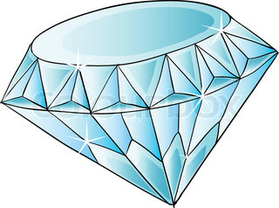**Primærtid:**

Ugentlig skallering:

|  |  |  |  |  |  |  |  |  |  |  |  |
| --- | --- | --- | --- | --- | --- | --- | --- | --- | --- | --- | --- |
| 10 |  |  |  |  |  |  |  |  |  |  |  |
| 9 |  |  |  |  |  |  |  |  |  |  |  |
| 8 |  |  |  |  |  |  |  |  |  |  |  |
| 7 |  |  |  |  |  |  |  |  |  |  |  |
| 6 |  |  |  |  |  |  |  |  |  |  |  |
| 5 |  |  |  |  |  |  |  |  |  |  |  |
| 4 |  |  |  |  |  |  |  |  |  |  |  |
| 3 |  |  |  |  |  |  |  |  |  |  |  |
| 2 |  |  |  |  |  |  |  |  |  |  |  |
| 1 |  |  |  |  |  |  |  |  |  |  |  |
| 0 | **P1** | **P2** | **P3** | **P4** | **P5** | **P6** | **P7** | **P8** | **P9** | **P10** | **P11** |